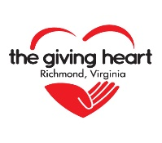
The Giving Heart Community Thanksgiving Feast
Donation Collections

Interested in helping us with donation needs for our Thanksgiving guests? Here are a few ways to be of service. Items are due at the Greater Richmond Convention Center, Exhibit Hall A on Wednesday, November 25th at 1 pm. Want to drop off earlier? Consider one of our drop off points around the area by contacting The Giving Heart at 749-4726 (7 days, 9 am to 11 pm). You can also email Vicki Neilson (vneilson@thegivingheart.org).

Prepared Giving Bags
To help minimize setup time and social distancing needs, please consider making prepared giving bag. Consider placing bags in boxes so that they can be stacked at our storage locations until needed.

Toiletry Bags (reusable bag with 4-8 items). MARK if it is for singles or families by adding a detachable note on the outside along with "Toiletries".
Food Bags (reusable bag with 4-8 nonperishable items). MARK if it is for singles or families by adding a detachable note on the outside along with "Food". Note that singles/couples love the pop up/easy open items!
General Mixed Bag (reusable bag with 4-8 items - food, toiletry, personal care, hats, gloves, scarves - does not have to be all of these!) MARK if it is for singles or families by adding a detachable note on the outside along with "Mixed Bag").
Blankets, sleeping bags, Lap blankets (place in boxes or bags and mark BLANKETS).
Hats, Gloves, Scarves, Socks (place in boxes or bags and mark CLOTHING ACCESSORIES).
Note: Go low in items for singles, higher for families. We will give 2 single bags for a couple). Unisex items are preferred but please feel free to add Male/Female if you want to do specific gender bags.

Bulk Items
We kindly accept bulk collections of singular items (i.e., diapers), neighborhood collection boxes, or other large quantity items that our volunteers will sort and make available to our guests. No need to create individual giving bags for these! A short list of commonly needed items is listed on the provided collection box sign but feel free to contact us with other ideas.

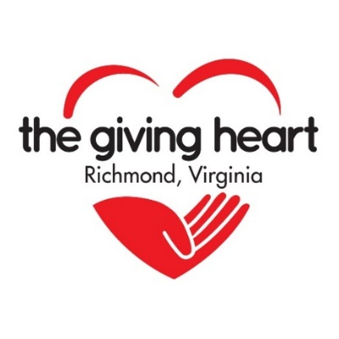

THE GIVING HEART
COMMUNITY THANKSGIVING FEAST
COLLECTION BOX

Donations are currently being accepted for items to be distributed at the Giving Heart’s Community Thanksgiving Feast. We appreciate your support!

- Reading Glasses
- Nonperishable Foods
- Toiletries
- Personal Care Products
- Reading Glasses
- Umbrellas
- Toilet Paper
- Adult/Youth Activity Books
New and Gently Used:
- Gloves
- Scarves
- Hats
- Coats/Jackets
- Blankets/Sleeping Bags
- Athletic Shoes
- Work Boots/Shoes

Questions? Contact The Giving Heart at 749-4726 or visit www.thegivingheart.org

