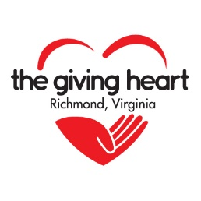

The Giving Heart
Secret Senior Valentine Bags

Thank you for your interest in The Giving Heart’s Secret Senior Valentine Bag Project. We appreciate the interest that this project has in our Community! We’ve listed below, some ideas for what you might wish to incorporate in your own gift bag. Each created bag should include a detachable label to identify it for male, female or unisex recipients. To keep everything simple this year, we are not creating any “personalized” bags, so feel free to create what you desire.

We encourage a minimum of 4-6 items per recipient. Unable to create bags this year? Please visit https://www.paypal.com/donate?hosted_button_id=UCN7CRM6SH7T4 to make a monetary donation.

Call or email The Giving Heart (info noted below) if you have items that you would love to pass on to our Seniors.

Suggested Senior Items

Shampoo
Conditioner
Soap
Deodorant
Toothpaste
Toothbrush
Lotion
Hand Sanitizer
Chap Stick
Tissues
Band Aids/First Aid Kit
Flashlight
2021 Calendar
Lighted Keychain
Socks
Hat
Scarf
Gloves
Lap Blanket
Umbrella
Nail Clippers
Adult Coloring Book
Colored Pencils
Crossword or Activity Book
Pens/Pencils
Current Magazine
Forever Stamps
Gift cards (grocery, fast food, etc.)
Candy (regular or diabetic)
Snacks or nonperishable food items

DEADLINE TO RECEIVE DONATIONS: February 3rd at The Giving Heart office.

Contact Information: The Giving Heart, 11527 Primrose Lane, Rockville, Va. 23146
(804) 749-4726. www.thegivingheart.org. Email: vneilson@thegivingheart.org

